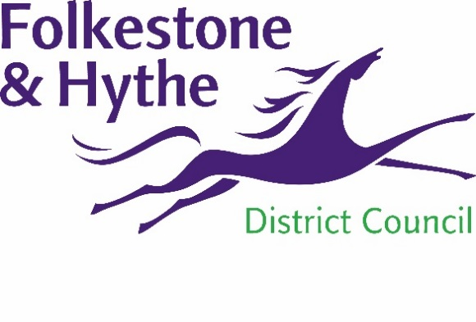
NEWS RELEASE

15 May 2020

TOWN CENTRE BOOST AS COUNCIL SUCCESSFULLY COMPLETES PURCHASE
Folkestone & Hythe District Council has successfully completed its purchase of the former Debenhams store in Sandgate Road, Folkestone.
Despite the disruptive effects of COVID-19 the council has pressed ahead to secure the store which will now become a centrepiece in Folkestone’s ongoing regeneration.
This proactive purchase builds on work the council has already been progressing, such as the High Street Fund and Folkestone Community Works initiatives.
Cllr David Monk, Leader of Folkestone & Hythe District Council said: “We’re committed to helping shape a more prosperous future for the district and this building is key to that aim. When Folkestone thrives as a destination the ripple effect and benefits from that will be felt throughout the district. Our commitment to this cause remains unwavering – despite COVID-19 – and I have every confidence that this bright future will prevail.”
Cllr Danny Brook, Folkestone Town Councillor for Folkestone Central Ward said: “I’m delighted that this purchase has gone through. The development of this building will provide a welcome boost for the town and it’s wonderful to have such positive news in these challenging times.”
The windows of the former Debenhams store will soon be animated with vinyl displays. The vibrant and detailed artwork is the result of collaboration between a number of independent businesses led by the Folkestone Independent Regeneration Retail Group (FIRGG), supported by F&HDC, which will brighten up the town centre.
Martyn Jackson, from FIRRG said: “This news will be welcomed by traders in Folkestone. I want to congratulate the council for securing a property so key to the regeneration of the town and we were delighted to be part of the team that delivered the content of the vinyls.”
Feedback from the town centre survey completed at the end of last year has also been released online. The results reflect an honest assessment of the town centre which outlines strengths and weaknesses common to many towns across the UK. Folkestone was praised for its independent shops, unique coastline and sense of community, while some issues were acknowledged such as the appeal of the town centre, empty shops and lack of leisure facilities. These findings have already helped shape the council’s economic development agenda. The full survey results can be viewed online at folkestone-hythe.gov.uk/business-growth
ENDS
Notes to Editors:
For more information, please email communications@folkestone-hythe.gov.uk

Follow us on Facebook: @FolkestoneandHytheDC
Follow us on Twitter: @fstonehythedc
Follow us on Instagram: @folkestonehythedc
Follow us on LinkedIn: Folkestone & Hythe District Council

